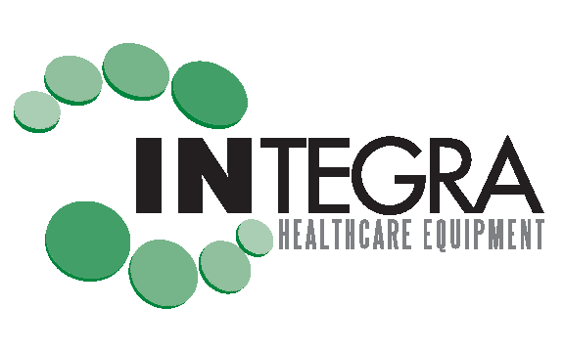

SERVICE TECHNICIAN /DRIVER

Integra Healthcare Equipment is a Durable Medical Equipment company providing patients with medical equipment for all their healthcare needs. We are looking for self-motivated drivers seeking an opportunity to be part of our excellent service team.

Job Summary:
The Service Technician/Driver is responsible for the delivery, set-up and instructional assistance of our medical equipment products to healthcare patients in skilled nursing facilities, hospice centers and personal referrals. You will receive hands on training of our equipment, vehicle training, and the delivery, pick-up and set up process.

DEPARTMENT- Service Technician
CITY: Elmhurst, IL
FULL TIME
SHIFT TYPE: Full Time
COMPENSATION: Non-Exempt (hourly) rate is based on experience of delivery of equipment.

REQUIREMENTS:
- Possess a valid driver license with a good driving record.
- Have completed High School or equivalent level of education.
- Must have excellent customer service skills.
- Able to lift or carry 95 lbs. or more.
- Box Truck Driver experience is not required but preferred.
- Comply with process of a background check, in accordance with local law/regulations.

Please apply

